***Task 1***

***Write a Java program that performs the following operations on a given string: find its length, convert it to uppercase, extract a substring, and replace a character.***

*public class StringOperations {*

*{*

*public static void main(String[] args) {*

*String input = "Hello, World!";*

*// Find the length of the string*

*int length = input.length();*

*System.out.println("Length of the string: " + length);*

*// Convert the string to uppercase*

*String upperCaseString = input.toUpperCase();*

*System.out.println("Uppercase string: " + upperCaseString);*

*// Extract a substring*

*//extracting "World" from "Hello, World!"*

*String substring = input.substring(7, 12);*

*System.out.println("Extracted substring: " + substring);*

*// Replace a character*

*//replacing 'o' with 'a'*

*String replacedString = input.replace('o', 'a');*

*System.out.println("String after replacement: " + replacedString);*

*}*

*}*

***Output:***

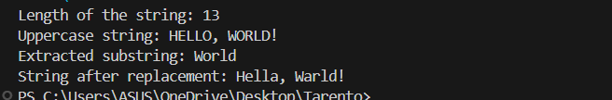

***Task 2***

***Write a Java program to parse a string into different primitive data types using wrapper class methods like parsent, parseDouble, parseBoolean, etc., and convert primitive types to strings using valueOf***

*public class ParseStringToPrimitives {*

*public static void main(String[] args) {*

*// Sample input Strings*

*String intString = "123";*

*String doubleString = "45.67";*

*String booleanString = "true";*

*String charString = "A";*

*// Parsing strings to primitive data types*

*int parsedInt = Integer.parseInt(intString);*

*double parsedDouble = Double.parseDouble(doubleString);*

*boolean parsedBoolean = Boolean.parseBoolean(booleanString);*

*char parsedChar = charString.charAt(0);  // Since char does not have a parse method*

*// Printing parsed values*

*System.out.println("Parsed int: " + parsedInt);*

*System.out.println("Parsed double: " + parsedDouble);*

*System.out.println("Parsed boolean: " + parsedBoolean);*

*System.out.println("Parsed char: " + parsedChar);*

*// Converting primitive types to strings using valueOf*

*String intToString = String.valueOf(parsedInt);*

*String doubleToString = String.valueOf(parsedDouble);*

*String booleanToString = String.valueOf(parsedBoolean);*

*String charToString = String.valueOf(parsedChar);*

*// Printing converted string values*

*System.out.println("String from int: " + intToString);*

*System.out.println("String from double: " + doubleToString);*

*System.out.println("String from boolean: " + booleanToString);*

*System.out.println("String from char: " + charToString);*

*}*

*}*

***OUTPUT:***

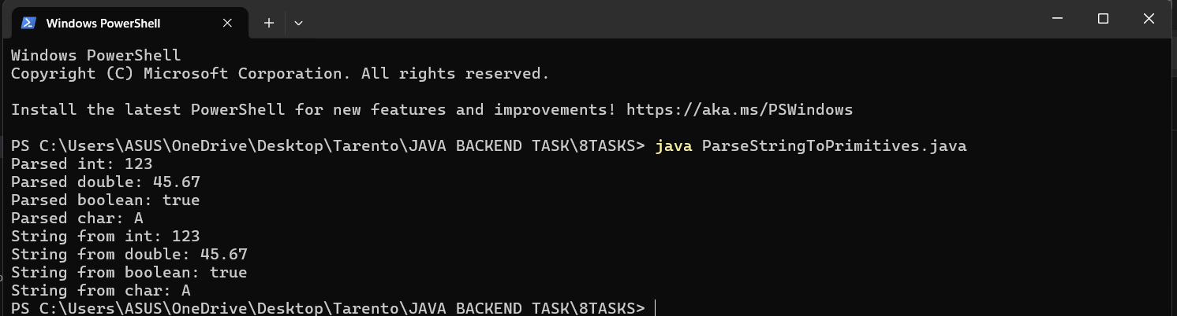

***Task 3***

***Write a Java program to sort an array of integers in ascending order using a sorting algorithm of your choice.***

*public class BubbleSort {*

*public static void main(String[] args) {*

*int[] array = {64, 34, 25, 12, 22, 11, 90};*

*System.out.println("Original array:");*

*printArray(array);*

*bubbleSort(array);*

*System.out.println("Sorted array in ascending order:");*

*printArray(array);*

*}*

*// Bubble Sort algorithm*

*public static void bubbleSort(int[] arr) {*

*int n = arr.length;*

*for (int i = 0; i < n - 1; i++) {*

*for (int j = 0; j < n - i - 1; j++) {*

*if (arr[j] > arr[j + 1]) {*

*// Swap arr[j] and arr[j + 1]*

*int temp = arr[j];*

*arr[j] = arr[j + 1];*

*arr[j + 1] = temp;*

*}*

*}*

*}*

*}*

*// method to print an array*

*public static void printArray(int[] arr) {*

*for (int num : arr) {*

*System.out.print(num + " ");*

*}*

*System.out.println();*

*}*

*}*

***OUTPUT:***

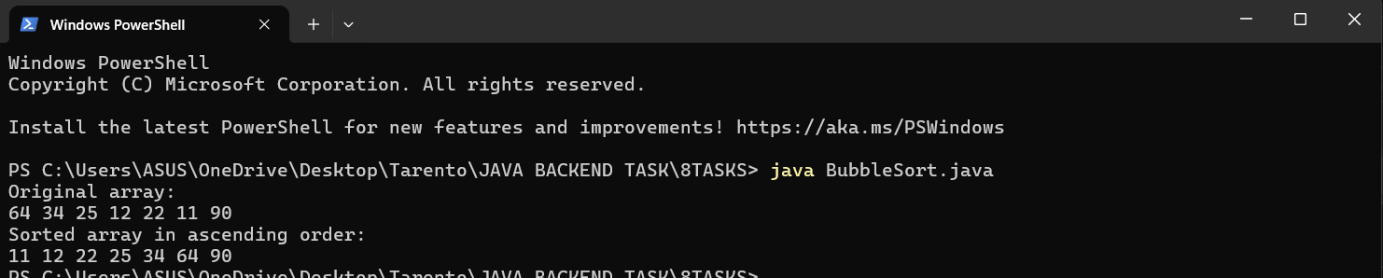

***Task 4***

***Use an ArrayList to store the list of books. Each book should have attributes such as title, author, ISBN, and price Implement functionalities to add new books, remove existing books, and display all books in the library.***

*import java.util.ArrayList;*

*import java.util.Scanner;*

*class Book {*

*private String title;*

*private String author;*

*private String ISBN;*

*private double price;*

*public Book(String title, String author, String ISBN, double price) {*

*this.title = title;*

*this.author = author;*

*this.ISBN = ISBN;*

*this.price = price;*

*}*

*public String getTitle() {*

*return title;*

*}*

*public String getAuthor() {*

*return author;*

*}*

*public String getISBN() {*

*return ISBN;*

*}*

*public double getPrice() {*

*return price;*

*}*

*@Override*

*public String toString() {*

*return "Book [Title=" + title + ", Author=" + author + ", ISBN=" + ISBN + ", Price=" + price + "]";*

*}*

*}*

*public class Library {*

*private ArrayList<Book> books;*

*public Library() {*

*books = new ArrayList<>();*

*}*

*// Add a new book to the library*

*public void addBook(Book book) {*

*books.add(book);*

*System.out.println("Book added: " + book);*

*}*

*// Remove an existing book from the library by ISBN*

*public void removeBook(String ISBN) {*

*Book bookToRemove = null;*

*for (Book book : books) {*

*if (book.getISBN().equals(ISBN)) {*

*bookToRemove = book;*

*break;*

*}*

*}*

*if (bookToRemove != null) {*

*books.remove(bookToRemove);*

*System.out.println("Book removed: " + bookToRemove);*

*} else {*

*System.out.println("Book with ISBN " + ISBN + " not found.");*

*}*

*}*

*// Display all books in the library*

*public void displayBooks() {*

*if (books.isEmpty()) {*

*System.out.println("No books in the library.");*

*} else {*

*System.out.println("Books in the library:");*

*for (Book book : books) {*

*System.out.println(book);*

*}*

*}*

*}*

*public static void main(String[] args) {*

*Library library = new Library();*

*Scanner scanner = new Scanner(System.in);*

*while (true) {*

*System.out.println("\nLibrary Menu:");*

*System.out.println("1. Add a book");*

*System.out.println("2. Remove a book");*

*System.out.println("3. Display all books");*

*System.out.println("4. Exit");*

*System.out.print("Enter your choice: ");*

*int choice = scanner.nextInt();*

*scanner.nextLine(); // Consume newline*

*switch (choice) {*

*case 1:*

*System.out.print("Enter title: ");*

*String title = scanner.nextLine();*

*System.out.print("Enter author: ");*

*String author = scanner.nextLine();*

*System.out.print("Enter ISBN: ");*

*String ISBN = scanner.nextLine();*

*System.out.print("Enter price: ");*

*double price = scanner.nextDouble();*

*scanner.nextLine(); // Consume newline*

*library.addBook(new Book(title, author, ISBN, price));*

*break;*

*case 2:*

*System.out.print("Enter ISBN of the book to remove: ");*

*String isbnToRemove = scanner.nextLine();*

*library.removeBook(isbnToRemove);*

*break;*

*case 3:*

*library.displayBooks();*

*break;*

*case 4:*

*System.out.println("Exiting the library system. Goodbye!");*

*scanner.close();*

*System.exit(0);*

*default:*

*System.out.println("Invalid choice. Please try again.");*

*}*

*}*

*}*

*}*

***OUTPUT:***

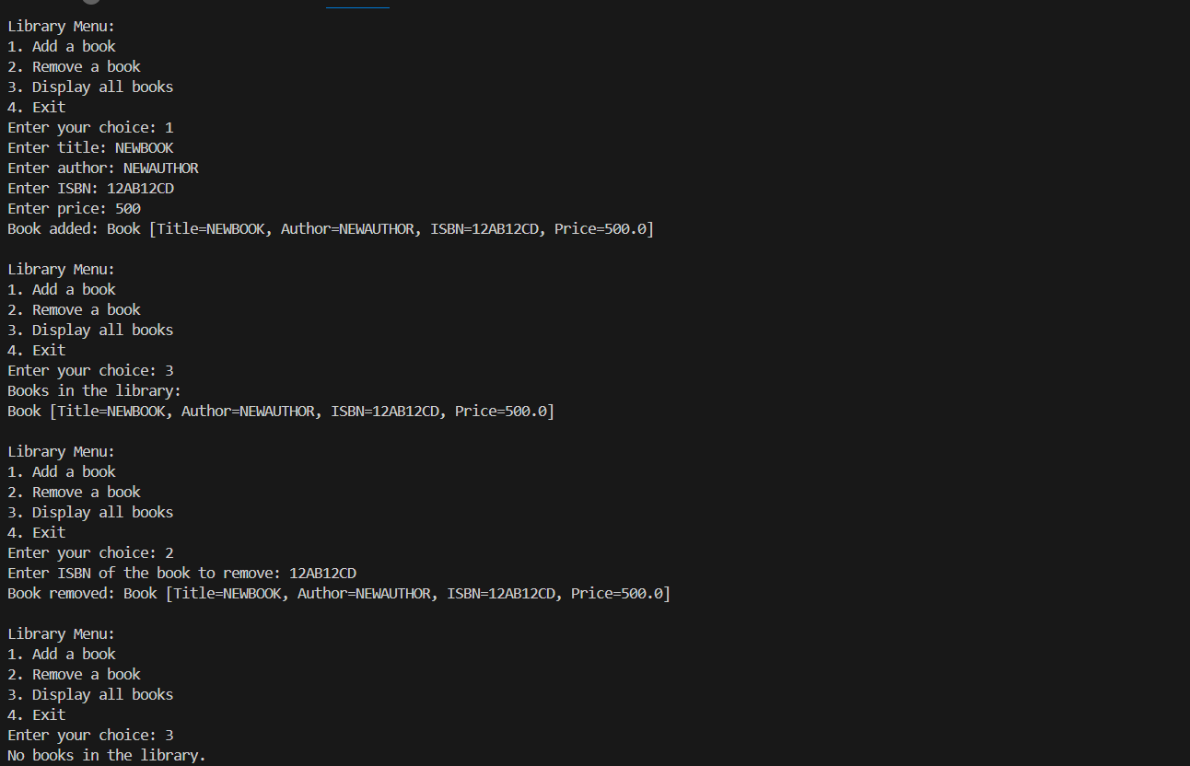

***Task 5***

***Use a HashSet to manage the unique genres available in the library. Ensure that new genres can be added without duplicating existing genres***

*import java.util.ArrayList;*

*import java.util.HashSet;*

*import java.util.Scanner;*

*class Book {*

*private String title;*

*private String author;*

*private String ISBN;*

*private double price;*

*private String genre;*

*public Book(String title, String author, String ISBN, double price, String genre) {*

*this.title = title;*

*this.author = author;*

*this.ISBN = ISBN;*

*this.price = price;*

*this.genre = genre;*

*}*

*public String getTitle() {*

*return title;*

*}*

*public String getAuthor() {*

*return author;*

*}*

*public String getISBN() {*

*return ISBN;*

*}*

*public double getPrice() {*

*return price;*

*}*

*public String getGenre() {*

*return genre;*

*}*

*@Override*

*public String toString() {*

*return "Book [Title=" + title + ", Author=" + author + ", ISBN=" + ISBN + ", Price=" + price + ", Genre=" + genre + "]";*

*}*

*}*

*public class Library {*

*private ArrayList<Book> books;*

*private HashSet<String> genres;*

*public Library() {*

*books = new ArrayList<>();*

*genres = new HashSet<>();*

*}*

*// Add a new book to the library*

*public void addBook(Book book) {*

*books.add(book);*

*genres.add(book.getGenre()); // Add genre to the set*

*System.out.println("Book added: " + book);*

*}*

*// Remove an existing book from the library by ISBN*

*public void removeBook(String ISBN) {*

*Book bookToRemove = null;*

*for (Book book : books) {*

*if (book.getISBN().equals(ISBN)) {*

*bookToRemove = book;*

*break;*

*}*

*}*

*if (bookToRemove != null) {*

*books.remove(bookToRemove);*

*System.out.println("Book removed: " + bookToRemove);*

*} else {*

*System.out.println("Book with ISBN " + ISBN + " not found.");*

*}*

*}*

*// Display all books in the library*

*public void displayBooks() {*

*if (books.isEmpty()) {*

*System.out.println("No books in the library.");*

*} else {*

*System.out.println("Books in the library:");*

*for (Book book : books) {*

*System.out.println(book);*

*}*

*}*

*}*

*// Display all unique genres in the library*

*public void displayGenres() {*

*if (genres.isEmpty()) {*

*System.out.println("No genres available.");*

*} else {*

*System.out.println("Genres available in the library:");*

*for (String genre : genres) {*

*System.out.println(genre);*

*}*

*}*

*}*

*public static void main(String[] args) {*

*Library library = new Library();*

*Scanner scanner = new Scanner(System.in);*

*while (true) {*

*System.out.println("\nLibrary Menu:");*

*System.out.println("1. Add a book");*

*System.out.println("2. Remove a book");*

*System.out.println("3. Display all books");*

*System.out.println("4. Display all genres");*

*System.out.println("5. Exit");*

*System.out.print("Enter your choice: ");*

*int choice = scanner.nextInt();*

*scanner.nextLine(); // Consume newline*

*switch (choice) {*

*case 1:*

*System.out.print("Enter title: ");*

*String title = scanner.nextLine();*

*System.out.print("Enter author: ");*

*String author = scanner.nextLine();*

*System.out.print("Enter ISBN: ");*

*String ISBN = scanner.nextLine();*

*System.out.print("Enter price: ");*

*double price = scanner.nextDouble();*

*scanner.nextLine(); // Consume newline*

*System.out.print("Enter genre: ");*

*String genre = scanner.nextLine();*

*library.addBook(new Book(title, author, ISBN, price, genre));*

*break;*

*case 2:*

*System.out.print("Enter ISBN of the book to remove: ");*

*String isbnToRemove = scanner.nextLine();*

*library.removeBook(isbnToRemove);*

*break;*

*case 3:*

*library.displayBooks();*

*break;*

*case 4:*

*library.displayGenres();*

*break;*

*case 5:*

*System.out.println("Exiting the library system. Goodbye!");*

*scanner.close();*

*System.exit(0);*

*default:*

*System.out.println("Invalid choice. Please try again.");*

*}*

*}*

*}*

*}*

***OUTPUT:***

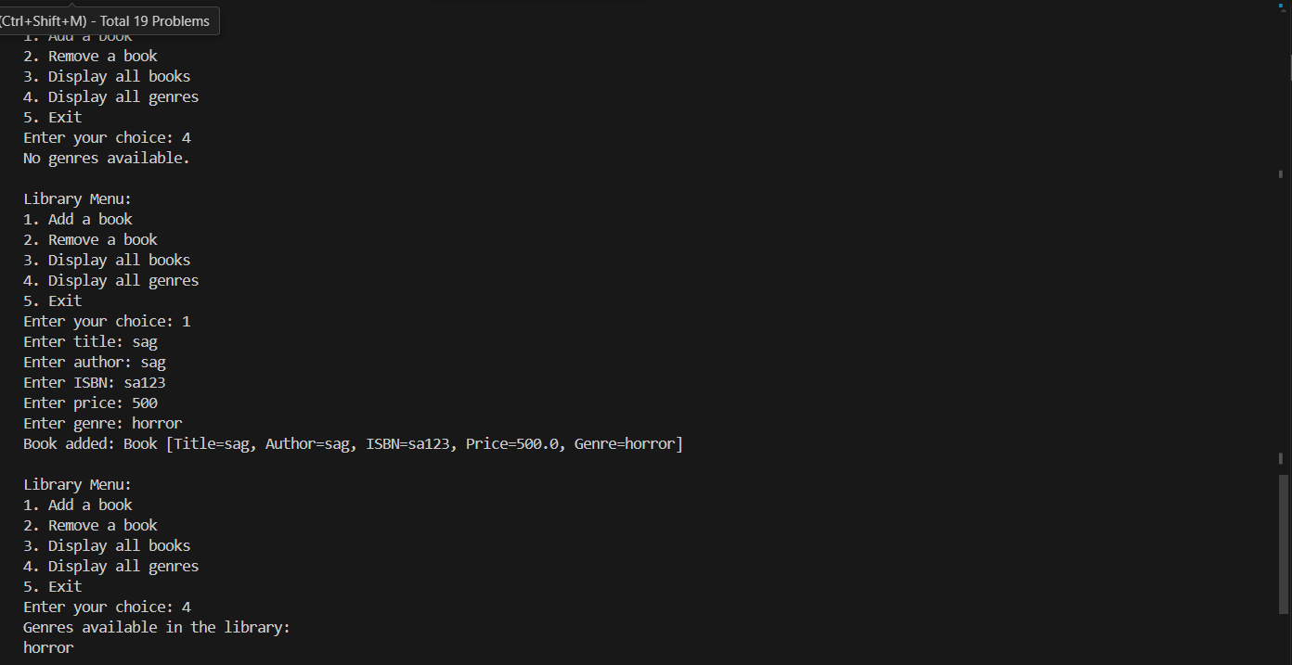

***Task 6***

***Use a HashMap to map ISBN numbers to books for quick lookup. Implement functionalities to add, update, and retrieve book details using ISBN.***

*import java.util.HashMap;*

*import java.util.HashSet;*

*import java.util.Scanner;*

*class Book {*

*private String title;*

*private String author;*

*private String ISBN;*

*private double price;*

*private String genre;*

*public Book(String title, String author, String ISBN, double price, String genre) {*

*this.title = title;*

*this.author = author;*

*this.ISBN = ISBN;*

*this.price = price;*

*this.genre = genre;*

*}*

*public String getTitle() {*

*return title;*

*}*

*public String getAuthor() {*

*return author;*

*}*

*public String getISBN() {*

*return ISBN;*

*}*

*public double getPrice() {*

*return price;*

*}*

*public String getGenre() {*

*return genre;*

*}*

*@Override*

*public String toString() {*

*return "Book [Title=" + title + ", Author=" + author + ", ISBN=" + ISBN + ", Price=" + price + ", Genre=" + genre + "]";*

*}*

*}*

*public class Library {*

*private HashMap<String, Book> books;*

*private HashSet<String> genres;*

*public Library() {*

*books = new HashMap<>();*

*genres = new HashSet<>();*

*}*

*// Add a new book to the library*

*public void addBook(Book book) {*

*books.put(book.getISBN(), book);*

*genres.add(book.getGenre()); // Add genre to the set*

*System.out.println("Book added: " + book);*

*}*

*// Update an existing book in the library by ISBN*

*public void updateBook(String ISBN, Book updatedBook) {*

*if (books.containsKey(ISBN)) {*

*books.put(ISBN, updatedBook);*

*genres.add(updatedBook.getGenre()); // Add or update genre*

*System.out.println("Book updated: " + updatedBook);*

*} else {*

*System.out.println("Book with ISBN " + ISBN + " not found.");*

*}*

*}*

*// Remove an existing book from the library by ISBN*

*public void removeBook(String ISBN) {*

*Book bookToRemove = books.remove(ISBN);*

*if (bookToRemove != null) {*

*System.out.println("Book removed: " + bookToRemove);*

*} else {*

*System.out.println("Book with ISBN " + ISBN + " not found.");*

*}*

*}*

*// Retrieve and display a book by ISBN*

*public void getBook(String ISBN) {*

*Book book = books.get(ISBN);*

*if (book != null) {*

*System.out.println("Book found: " + book);*

*} else {*

*System.out.println("Book with ISBN " + ISBN + " not found.");*

*}*

*}*

*// Display all books in the library*

*public void displayBooks() {*

*if (books.isEmpty()) {*

*System.out.println("No books in the library.");*

*} else {*

*System.out.println("Books in the library:");*

*for (Book book : books.values()) {*

*System.out.println(book);*

*}*

*}*

*}*

*// Display all unique genres in the library*

*public void displayGenres() {*

*if (genres.isEmpty()) {*

*System.out.println("No genres available.");*

*} else {*

*System.out.println("Genres available in the library:");*

*for (String genre : genres) {*

*System.out.println(genre);*

*}*

*}*

*}*

*public static void main(String[] args) {*

*Library library = new Library();*

*Scanner scanner = new Scanner(System.in);*

*while (true) {*

*System.out.println("\nLibrary Menu:");*

*System.out.println("1. Add a book");*

*System.out.println("2. Update a book");*

*System.out.println("3. Remove a book");*

*System.out.println("4. Retrieve a book by ISBN");*

*System.out.println("5. Display all books");*

*System.out.println("6. Display all genres");*

*System.out.println("7. Exit");*

*System.out.print("Enter your choice: ");*

*int choice = scanner.nextInt();*

*scanner.nextLine(); // Consume newline*

*switch (choice) {*

*case 1:*

*System.out.print("Enter title: ");*

*String title = scanner.nextLine();*

*System.out.print("Enter author: ");*

*String author = scanner.nextLine();*

*System.out.print("Enter ISBN: ");*

*String ISBN = scanner.nextLine();*

*System.out.print("Enter price: ");*

*double price = scanner.nextDouble();*

*scanner.nextLine(); // Consume newline*

*System.out.print("Enter genre: ");*

*String genre = scanner.nextLine();*

*library.addBook(new Book(title, author, ISBN, price, genre));*

*break;*

*case 2:*

*System.out.print("Enter ISBN of the book to update: ");*

*String isbnToUpdate = scanner.nextLine();*

*System.out.print("Enter new title: ");*

*String newTitle = scanner.nextLine();*

*System.out.print("Enter new author: ");*

*String newAuthor = scanner.nextLine();*

*System.out.print("Enter new price: ");*

*double newPrice = scanner.nextDouble();*

*scanner.nextLine(); // Consume newline*

*System.out.print("Enter new genre: ");*

*String newGenre = scanner.nextLine();*

*library.updateBook(isbnToUpdate, new Book(newTitle, newAuthor, isbnToUpdate, newPrice, newGenre));*

*break;*

*case 3:*

*System.out.print("Enter ISBN of the book to remove: ");*

*String isbnToRemove = scanner.nextLine();*

*library.removeBook(isbnToRemove);*

*break;*

*case 4:*

*System.out.print("Enter ISBN of the book to retrieve: ");*

*String isbnToRetrieve = scanner.nextLine();*

*library.getBook(isbnToRetrieve);*

*break;*

*case 5:*

*library.displayBooks();*

*break;*

*case 6:*

*library.displayGenres();*

*break;*

*case 7:*

*System.out.println("Exiting the library system. Goodbye!");*

*scanner.close();*

*System.exit(0);*

*default:*

*System.out.println("Invalid choice. Please try again.");*

*}*

*}*

*}*

*}*

***OUTPUT:***

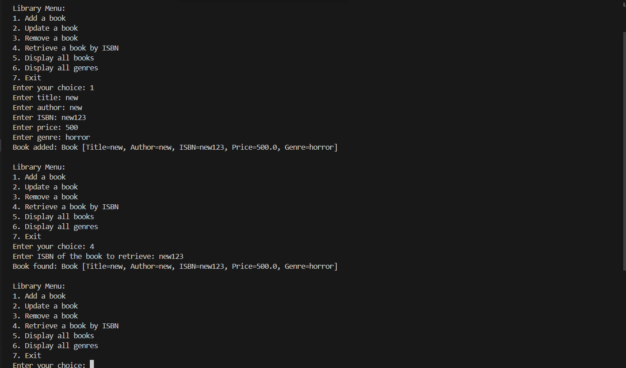

***Task 7***

***Implement a custom exception called ProductNotFoundException that is thrown when a product is not found in the inventory. Use try, catch, finally, throw, and throws to handle exceptions appropriately.***

*public class ProductNotFoundException extends Exception {*

*public ProductNotFoundException(String message) {*

*super(message);*

*}*

*}*

*import java.util.HashMap;*

*import java.util.HashSet;*

*import java.util.Scanner;*

*class Book {*

*private String title;*

*private String author;*

*private String ISBN;*

*private double price;*

*private String genre;*

*public Book(String title, String author, String ISBN, double price, String genre) {*

*this.title = title;*

*this.author = author;*

*this.ISBN = ISBN;*

*this.price = price;*

*this.genre = genre;*

*}*

*public String getTitle() {*

*return title;*

*}*

*public String getAuthor() {*

*return author;*

*}*

*public String getISBN() {*

*return ISBN;*

*}*

*public double getPrice() {*

*return price;*

*}*

*public String getGenre() {*

*return genre;*

*}*

*@Override*

*public String toString() {*

*return "Book [Title=" + title + ", Author=" + author + ", ISBN=" + ISBN + ", Price=" + price + ", Genre=" + genre + "]";*

*}*

*}*

*public class Library {*

*private HashMap<String, Book> books;*

*private HashSet<String> genres;*

*public Library() {*

*books = new HashMap<>();*

*genres = new HashSet<>();*

*}*

*// Add a new book to the library*

*public void addBook(Book book) {*

*books.put(book.getISBN(), book);*

*genres.add(book.getGenre()); // Add genre to the set*

*System.out.println("Book added: " + book);*

*}*

*// Update an existing book in the library by ISBN*

*public void updateBook(String ISBN, Book updatedBook) throws ProductNotFoundException {*

*if (books.containsKey(ISBN)) {*

*books.put(ISBN, updatedBook);*

*genres.add(updatedBook.getGenre()); // Add or update genre*

*System.out.println("Book updated: " + updatedBook);*

*} else {*

*throw new ProductNotFoundException("Book with ISBN " + ISBN + " not found.");*

*}*

*}*

*// Remove an existing book from the library by ISBN*

*public void removeBook(String ISBN) throws ProductNotFoundException {*

*Book bookToRemove = books.remove(ISBN);*

*if (bookToRemove != null) {*

*System.out.println("Book removed: " + bookToRemove);*

*} else {*

*throw new ProductNotFoundException("Book with ISBN " + ISBN + " not found.");*

*}*

*}*

*// Retrieve and display a book by ISBN*

*public void getBook(String ISBN) throws ProductNotFoundException {*

*Book book = books.get(ISBN);*

*if (book != null) {*

*System.out.println("Book found: " + book);*

*} else {*

*throw new ProductNotFoundException("Book with ISBN " + ISBN + " not found.");*

*}*

*}*

*// Display all books in the library*

*public void displayBooks() {*

*if (books.isEmpty()) {*

*System.out.println("No books in the library.");*

*} else {*

*System.out.println("Books in the library:");*

*for (Book book : books.values()) {*

*System.out.println(book);*

*}*

*}*

*}*

*// Display all unique genres in the library*

*public void displayGenres() {*

*if (genres.isEmpty()) {*

*System.out.println("No genres available.");*

*} else {*

*System.out.println("Genres available in the library:");*

*for (String genre : genres) {*

*System.out.println(genre);*

*}*

*}*

*}*

*public static void main(String[] args) {*

*Library library = new Library();*

*Scanner scanner = new Scanner(System.in);*

*while (true) {*

*System.out.println("\nLibrary Menu:");*

*System.out.println("1. Add a book");*

*System.out.println("2. Update a book");*

*System.out.println("3. Remove a book");*

*System.out.println("4. Retrieve a book by ISBN");*

*System.out.println("5. Display all books");*

*System.out.println("6. Display all genres");*

*System.out.println("7. Exit");*

*System.out.print("Enter your choice: ");*

*int choice = scanner.nextInt();*

*scanner.nextLine(); // Consume newline*

*try {*

*switch (choice) {*

*case 1:*

*System.out.print("Enter title: ");*

*String title = scanner.nextLine();*

*System.out.print("Enter author: ");*

*String author = scanner.nextLine();*

*System.out.print("Enter ISBN: ");*

*String ISBN = scanner.nextLine();*

*System.out.print("Enter price: ");*

*double price = scanner.nextDouble();*

*scanner.nextLine(); // Consume newline*

*System.out.print("Enter genre: ");*

*String genre = scanner.nextLine();*

*library.addBook(new Book(title, author, ISBN, price, genre));*

*break;*

*case 2:*

*System.out.print("Enter ISBN of the book to update: ");*

*String isbnToUpdate = scanner.nextLine();*

*System.out.print("Enter new title: ");*

*String newTitle = scanner.nextLine();*

*System.out.print("Enter new author: ");*

*String newAuthor = scanner.nextLine();*

*System.out.print("Enter new price: ");*

*double newPrice = scanner.nextDouble();*

*scanner.nextLine(); // Consume newline*

*System.out.print("Enter new genre: ");*

*String newGenre = scanner.nextLine();*

*library.updateBook(isbnToUpdate, new Book(newTitle, newAuthor, isbnToUpdate, newPrice, newGenre));*

*break;*

*case 3:*

*System.out.print("Enter ISBN of the book to remove: ");*

*String isbnToRemove = scanner.nextLine();*

*library.removeBook(isbnToRemove);*

*break;*

*case 4:*

*System.out.print("Enter ISBN of the book to retrieve: ");*

*String isbnToRetrieve = scanner.nextLine();*

*library.getBook(isbnToRetrieve);*

*break;*

*case 5:*

*library.displayBooks();*

*break;*

*case 6:*

*library.displayGenres();*

*break;*

*case 7:*

*System.out.println("Exiting the library system. Goodbye!");*

*scanner.close();*

*System.exit(0);*

*default:*

*System.out.println("Invalid choice. Please try again.");*

*}*

*} catch (ProductNotFoundException e) {*

*System.out.println(e.getMessage());*

*} finally {*

*// Code that should always run, e.g., closing resources, can go here*

*}*

*}*

*}*

*}*

***OUTPUT:***

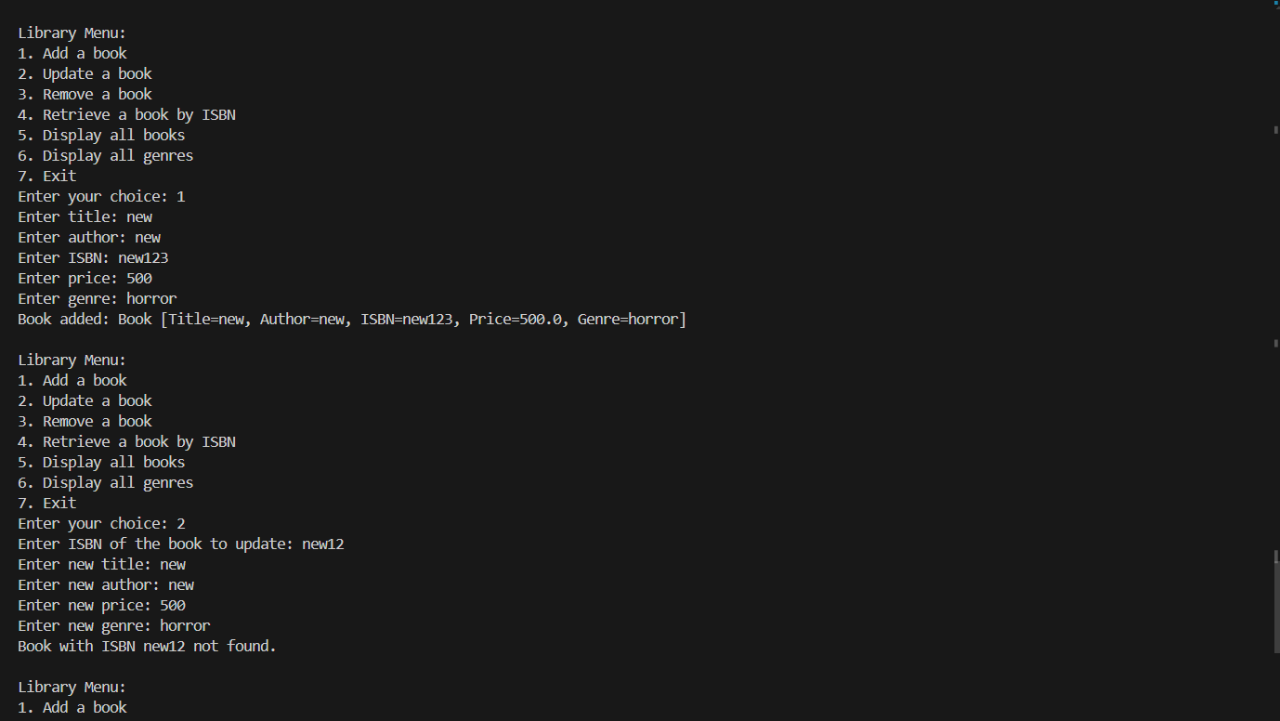

***Task 8***

***Use any one of the file handling to read employee records from a text file and write employee records to a text file***

*import java.io.*;*

*import java.util.ArrayList;*

*import java.util.List;*

*// Employee class*

*class Employee {*

*private String id;*

*private String name;*

*private String position;*

*public Employee(String id, String name, String position) {*

*this.id = id;*

*this.name = name;*

*this.position = position;*

*}*

*public String getId() {*

*return id;*

*}*

*public String getName() {*

*return name;*

*}*

*public String getPosition() {*

*return position;*

*}*

*@Override*

*public String toString() {*

*return id + "," + name + "," + position;*

*}*

*}*

*// FileHandler class*

*class FileHandler {*

*// Read employee records from a file*

*public static List<Employee> readEmployeesFromFile(String filePath) {*

*List<Employee> employees = new ArrayList<>();*

*try (BufferedReader reader = new BufferedReader(new FileReader(filePath))) {*

*String line;*

*while ((line = reader.readLine()) != null) {*

*String[] parts = line.split(",");*

*if (parts.length == 3) {*

*Employee employee = new Employee(parts[0], parts[1], parts[2]);*

*employees.add(employee);*

*}*

*}*

*} catch (IOException e) {*

*e.printStackTrace();*

*}*

*return employees;*

*}*

*// Write employee records to a file*

*public static void writeEmployeesToFile(String filePath, List<Employee> employees) {*

*try (BufferedWriter writer = new BufferedWriter(new FileWriter(filePath))) {*

*for (Employee employee : employees) {*

*writer.write(employee.toString());*

*writer.newLine();*

*}*

*} catch (IOException e) {*

*e.printStackTrace();*

*}*

*}*

*}*

*// Main class*

*public class Main {*

*public static void main(String[] args) {*

*String inputFilePath = "C:\\Users\\ASUS\\OneDrive\\Desktop\\Tarento\\JAVA BACKEND TASK\\8TASKS\\employees.txt";*

*String outputFilePath = "C:\\Users\\ASUS\\OneDrive\\Desktop\\Tarento\\JAVA BACKEND TASK\\8TASKS\\output_employees.txt";*

*// Read employee records from file*

*List<Employee> employees = FileHandler.readEmployeesFromFile(inputFilePath);*

*// Optionally, print out the employees to verify*

*System.out.println("Employees read from file:");*

*for (Employee employee : employees) {*

*System.out.println(employee);*

*}*

*// Write employee records to a new file*

*FileHandler.writeEmployeesToFile(outputFilePath, employees);*

*System.out.println("\nEmployee records have been written to " + outputFilePath);*

*}*

*}*

***OUTPUT:***

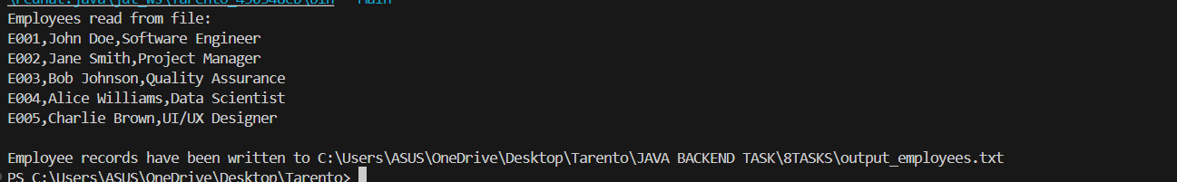

***employees.txt***

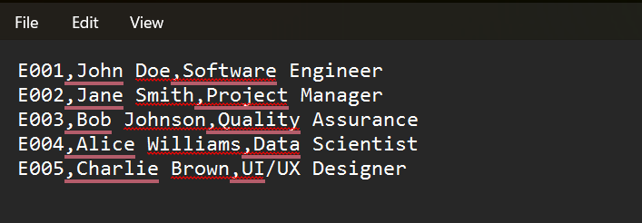

***Output_employees.txt***

